**Professional Certificate in Artificial Intelligence and Machine Learning**

**Capstone Project**

**Fernando Nimer, PhD**

**“Predicting the Probability of an ArXiv.org Research Paper Being Published in a Journal”**

**Final Report**

Table of Contents:

**1. Problem Statement** 2

**2. Model Outcomes or Predictions** 3

**3. Data Acquisition** 4

**4. Handling Missing Values and Inconsistencies** 5

**5. Modeling** 9

**6. Model Evaluation and Recommendations** 14

**Appendix 1. Detailed Plots** 21

## **1. Problem Statement**

**Problem Statement:**The goal of this project is to predict whether a research paper on <https://arxiv.org/> will be published in a journal. This prediction can help researchers identify high-quality papers to prioritize their reading. The prediction can also help researchers customize their approaches to maximize the probability of having their papers published. The target variable is a binary response variable (y), indicating whether a paper is published (1) or not (0).

**Why This Question Is Important:**  
Not all papers on <https://arxiv.org/> are published in journals, and published papers are often considered higher quality due to the peer-review process. By predicting publication likelihood, this project can save researchers considerable time by directing them to potentially higher-quality papers first, improving the efficiency of their literature review process. The factors affecting the likelihood of publication can also be leveraged by authors seeking to maximize the publication of their papers in the future.

**Note: Brief Considerations on Relating Publication with High Paper Quality**

The assumption that journal publication equates to higher paper quality is an imperfect proxy. While publication in a peer-reviewed journal is often used as an indicator of quality due to the vetting process and peer reviews, this approach has important limitations. The relationship between publication and quality can be misleading due to factors such as selective submission practices - authors may preferentially submit their best work for publication, or prominent researchers may receive preferential treatment, inflating the perceived quality of published papers. Additionally, acceptance decisions in journals and conferences are influenced by subjective reviewer judgments, institutional prestige, the need to publish a certain, high visible topic, and other biases, meaning that not all high-quality papers are published, and not all published work is of high quality. Therefore, using publication status as a proxy for paper quality risks confounding content quality with paper visibility, author’s reputation, or strategic behavior rather than objective merit on the paper quality. As a conclusion, while publication is correlated with quality, it is not a definitive or unbiased measure, and the model’s predictions should be interpreted as such.

## **2. Model Outcomes or Predictions**

**Type of Learning:**This is a supervised classification problem, as the goal is to predict a binary outcome, that is, a binary response variable (y), indicating whether a research paper is published (y = 1) or not (y = 0).

**Expected Outputs:**

* The target variable is a binary response (y), determined by the column journal-ref in the dataset:
  + If journal-ref is NaN, the paper is considered "not published."
  + If journal-ref contains content, that is, the name of a journal or publication vehicle, the paper is considered "published."
  + Note: for simplification, we assume that a paper with NaN value in the column journal-ref failed in its publication efforts, which may not be true in all cases (for example, the author may be waiting for a future, already approved publication).

By training eight (8) types of models on this data, we aim to determine whether a given paper will be published based on its features. We will also seek the best model to classify this problem given the existing data. We will also analyze the most relevant features affecting the likelihood of a publication.

## **3. Data Acquisition**

**Data Sources:**  
The data for this project comes from two metadata files about the <https://arxiv.org/> papers available on Kaggle:

1. ArXiv Metadata OAI Snapshot
   * Source: <https://www.kaggle.com/datasets/Cornell-University/arxiv>
   * Filename: arxiv-metadata-oai-snapshot.json
2. ArXiv Paper Abstracts
   * Source: <https://www.kaggle.com/datasets/spsayakpaul/arxiv-paper-abstracts>
   * Filename: arxi_data.csv

**Dataset Size:**

The combined dataset has 11,597 rows. Each row contains data about a single research paper published on <https://arxiv.org/> where the column “categories” is equal to ‘cs.AI’ ”.

**Metadata:**

The datasets contain metadata about research papers submitted to <https://arxiv.org/>. The metadata includes key features such as authors, title, abstract, submission date, categories, and journal references. The second dataset uses different column names but was normalized during preprocessing to ensure consistency with the first dataset.

Key Features in the Metadata:

* id: Unique identifier for each paper.
* submitter: User who submitted the paper.
* authors: List of contributing authors.
* title: Title of the paper.
* abstract: Summary of the paper's content.
* journal-ref: Reference to the journal where the paper was published (if applicable).
  + Note: this is the source of our target variable (y)
* categories: Subject areas (e.g., cs.AI, math.ST).
* comments: Additional submission details or revision notes.
* doi: Digital Object Identifier (if available).
* update_date: Date when the paper was last updated on <https://arxiv.org/>.

## **4. Handling Missing Values and Inconsistencies**

The preprocessing step is complex and runs for almost 60 minutes.

It combines the two above-mentioned datasets and processes the following steps, generating a single output JSON file that will be used in the modeling phase:

**Missing Values and Normalization:**

1. Identifying Missing Values:
   * The journal-ref column, which serves as the target variable, contains NaN values for papers that are not published. These values were retained as they represent a meaningful category for prediction.
   * Other important columns like title and abstract were checked for missing values. Rows with missing values were removed, except for the columns title or abstract, as these two features are critical for text-based analysis and the target variable; in this case, missing values means “y = 0”.
2. Normalizing Column Names:
   * The datasets from diverse sources had inconsistent column names. These were standardized to ensure uniformity (e.g., renaming columns like comment and comments to match across both datasets).

**Data Cleaning Steps:**

1. Duplicate Removal:
   * Duplicate rows were identified and removed based on the unique id column to avoid redundancy in the dataset.
2. Standardizing Text Fields:
   * The title and abstract fields were converted to lowercase to ensure case-insensitive processing.
   * Special characters, extra whitespace, and non-alphanumeric symbols were removed using regular expressions to clean the text data.

**Feature Engineering:**

1. Text-Based Features:
   * Abstract Length: The number of words in the abstract was calculated and added as a feature (abstract_length).
   * Title Word Count: The number of words in the title was calculated and added as a feature (title_word_count).
   * We also searched for relevant words given a predefined set of the most relevant 500 AI-related keywords used to create new features and for counting their appearances in the text columns.
2. Categorical Features:
   * The categories column was one-hot encoded to represent the subject areas of the papers as binary features.
3. Text Embeddings:
   * We computed approximately 11,000 embedded features out of the columns title and abstract using TF-IDF and BERT algorithms. These features were properly named and stored in the output data frame for modeling purposes.

**Splitting Data into Training and Test Sets:**

* The cleaned dataset was split into training (80%) and test (20%) subsets using the train_test_split function from Scikit-learn. This ensures that the model is evaluated on unseen data.

**Encoding Categorical Variables:**

* The categorical variable categories, which contains subject classifications (e.g., "cs.AI"), was one-hot encoded using Scikit-Learn OneHotEncoder. This transformed each category into a separate binary feature, enabling its use in machine learning models.

This preprocessing pipeline ensures that the data is clean, consistent, and ready for modeling while retaining all relevant information necessary for accurate predictions.

New derived features were created in this process, especially the embeddings that were saved for the modeling phase.

Below are two examples of Word Cloud and Clusters for the title and abstract columns using BERT and k = 4:

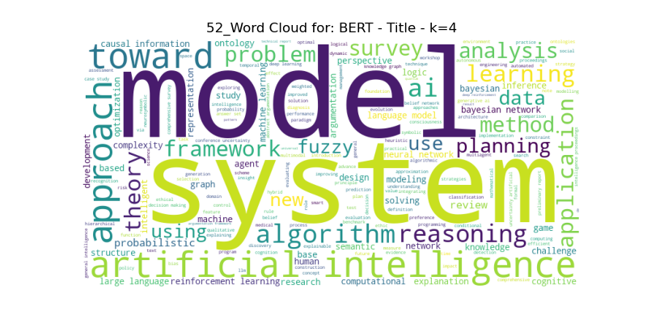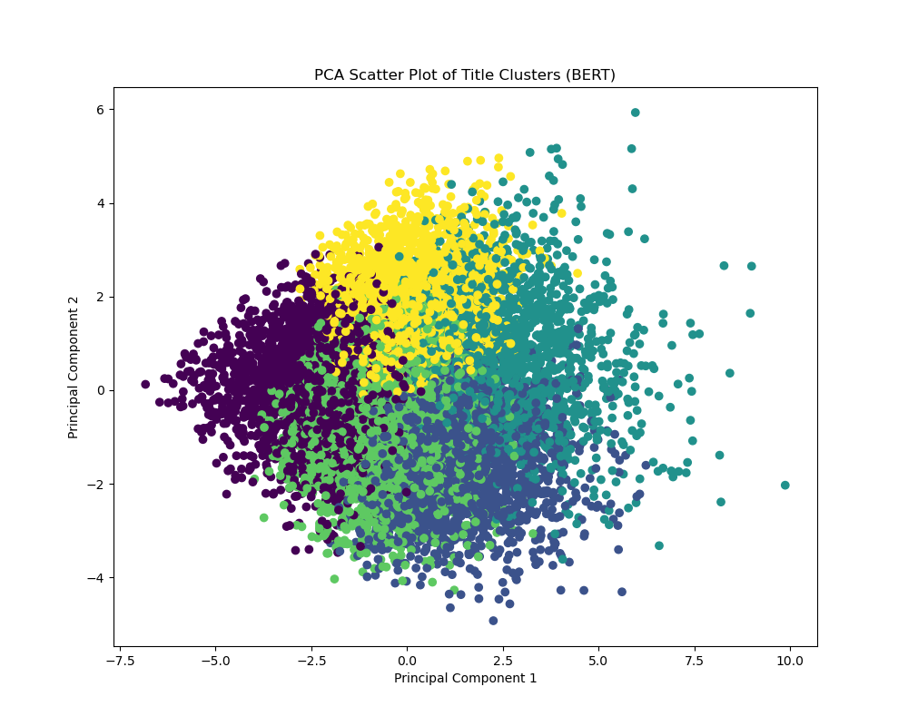

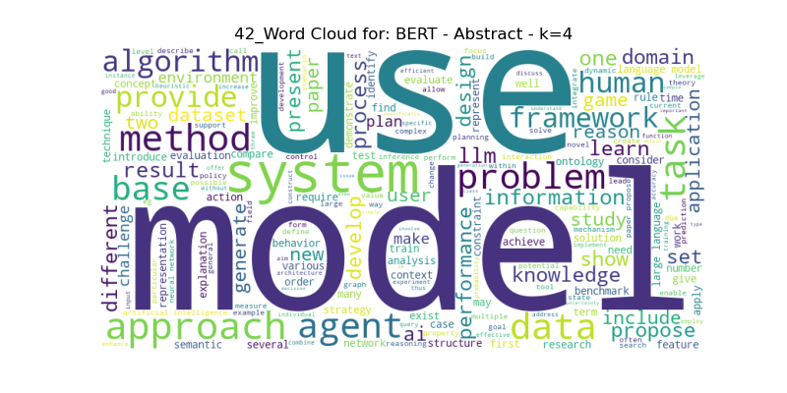

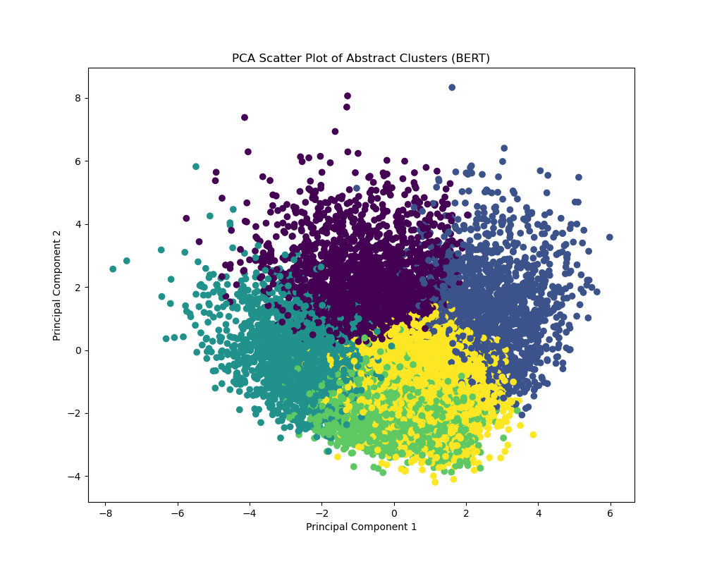

Appendix 1 contains all the 57 plots of the data originated from the Preprocessing Phase that provides more details about the data being used.

## **5. Modeling**

**Model Purpose:**

This model predicts the likelihood that a research paper posted on arXiv.org will eventually be published in a peer-reviewed journal. It helps researchers quickly identify which papers are more likely to be of higher quality, allowing them to prioritize their reading or refine their own submissions for better publication opportunities. The model analyzes features like keywords in the title and abstract, author history, size of the paper, and other features to make its predictions. Using advanced techniques, the three best models achieved high accuracy rates (around 87%), meaning it correctly predicts the publication status for most cases. However, users should remember that publication is only a proxy for quality, and the model’s predictions should be used as a helpful guide rather than an absolute measure

**Modeling Techniques:**

The following techniques were used for analysis and predictive modeling:

Text Embedding Techniques

1. TF-IDF (Term Frequency-Inverse Document Frequency):
   * Applied to title and abstract fields to convert text into numerical vectors.
   * Parameters: max_features=5000 for dimensionality control.
2. BERT (Bidirectional Encoder Representations from Transformers):
   * Generated embeddings for title and abstract using bert-base-uncased with max_length=16 (due to computational constraints).
   * Reduced embeddings to 5 dimensions using PCA for integration into models.
3. Word Cloud and Word Count Analysis: To visualize and explore common terms in titles and abstracts.

Dimensionality Reduction and Clustering

1. PCA (Principal Component Analysis):
   * To reduce dimensionality for visualization or feature selection.
   * Reduced TF-IDF and BERT embeddings to 5 components for visualization and feature engineering.
2. K-Means Clustering:
   * To group similar papers based on embeddings. Used both in the modeling phase and in the preprocessing phase to create cluster variables.
   * Created cluster labels for abstracts and titles using both TF-IDF (n_clusters=5) and BERT embeddings (n_clusters=4).
   * Cluster labels were added as categorical features to enhance predictive power.

Predictive Modeling Algorithms:

The following supervised and unsupervised machine learning algorithms were trained and optimized:

|  |  |  |
| --- | --- | --- |
| **Algorithm** | **Hyperparameters Tuned via GridSearchCV** | **Key Features Used** |
| Logistic Regression | C (regularization strength) | TF-IDF, BERT embeddings, cluster labels |
| Decision Tree | gini, max_dept, min_samples_split, min_samples_leaf | All features |
| KNN | n_neighbors, weights-uniform, algorithm-auto | All features |
| Naive Bayes | alpha, fit_prior | All features |
| Random Forest | max_depth, n_estimators | Text embeddings + metadata features |
| Gradient Boosting | learning_rate, n_estimators | Combined TF-IDF and BERT features |
| SVM | C, kernel, gamma, tol | PCA-reduced embeddings |
| Neural Network | Layers: (64, 32), Activation: ReLU | BERT embeddings + cluster labels |

GridSearchCV final parameters:

The following parameters were applied to the models after the GridSearchCV:

param_grids = {

'Logistic Regression': {

'C': [100], # From optimized LogisticRegression

'penalty': ['l1'], # Matches optimized penalty

'solver': ['liblinear'], # Correct solver for L1 regularization

'max_iter': [1000], # Keep optimized iteration count

'class_weight': [None], # From optimization

'tol': [1e-06] # Matches optimized tolerance

},

'Decision Tree': {

'criterion': ['gini'], # From optimized DecisionTree

'max_depth': [5], # Matches optimized depth constraint

'min_samples_split': [2], # Maintains optimized split policy

'min_samples_leaf': [1] # Matches leaf node requirements

},

'Random Forest': {

'n_estimators': [200], # From optimized RandomForest

'max_features': ['sqrt'], # Matches feature selection strategy

'bootstrap': [True], # Maintain optimized resampling method

'min_samples_split': [2], # Keep optimized split threshold

'min_samples_leaf': [1] # Matches leaf node requirements

},

'SVM': {

'C': [0.1], # From optimized SVM parameters

'kernel': ['linear'], # Matches optimized kernel type

'gamma': ['scale'], # Maintain optimized scaling

'tol': [0.001] # Keep convergence tolerance

},

'KNN': {

'n_neighbors': [5], # From optimized KNN

'weights': ['uniform'], # Matches weighting strategy

'algorithm': ['auto'] # Maintain automatic algorithm selection

},

'Naive Bayes': {

'alpha': [0.1], # From optimized NaiveBayes

'fit_prior': [True] # Matches prior learning strategy

},

'Gradient Boosting': {

'n_estimators': [50], # From optimized GradientBoosting

'learning_rate': [0.1], # Matches optimized learning rate

'max_depth': [5], # Keep optimized depth constraint

'min_samples_split': [2], # Maintain split requirements

'min_samples_leaf': [1] # Match leaf node policy

},

'Neural Network': {

'hidden_layer_sizes': [(20,)], # From optimized architecture

'activation': ['relu'], # Matches activation function

'solver': ['adam'], # Keep optimized solver

'alpha': [0.0001], # Matches regularization strength

'max_iter': [1000], # Maintain iteration count

'tol': [0.0001] # Keep convergence tolerance

}

}

Sequential Feature Selection (SFS):

SFS was applied to all modules using the following parameters:

# Apply SFS with critical optimizations

for name, model in models.items():

# Configure common SFS parameters

sfs_params = {

'n_features_to_select': 0.5, # Explicit ratio instead of 'auto'

'direction': 'forward', # Consider bidirectional if relevant

'scoring': 'accuracy',

'cv': 3, # Reduced from 5 folds

'n_jobs': -1, # Enable parallel processing

'tol': 0.01 # Early stopping tolerance

}

# Create appropriate pipeline

if name in ['Logistic Regression', 'SVM', 'Neural Network']:

# Pipeline with scaling for sensitive models

pipeline = make_pipeline(StandardScaler(), model)

sfs = SequentialFeatureSelector(pipeline, **sfs_params)

else:

# Direct model for tree-based algorithms

sfs = SequentialFeatureSelector(model, **sfs_params)

# Fit SFS and transform data

sfs.fit(X_train, y_train)

X_train_sfs = sfs.transform(X_train)

X_test_sfs = sfs.transform(X_test)

Pipeline Architecture:

The pipeline architecture was created, and class imbalance was treated using the standard SMOTE package:

# Train final model with proper preprocessing

if name in ['Logistic Regression', 'SVM', 'Neural Network']:

pipeline.fit(X_train_sfs, y_train)

y_pred_test = pipeline.predict(X_test_sfs)

y_pred_train = pipeline.predict(X_train_sfs)

else:

model.fit(X_train_sfs, y_train)

y_pred_test = model.predict(X_test_sfs)

y_pred_train = model.predict(X_train_sfs)

# Train model with selected features

model.fit(X_train_sfs, y_train)

y_pred_train = model.predict(X_train_sfs)

y_pred_test = model.predict(X_test_sfs)

## **6. Model Evaluation and Recommendations**

**Evaluation Metrics:**  
The models were evaluated using the following metrics to assess their classification performance:

* Accuracy: The proportion of correctly classified samples.
* Precision: The ratio of true positives to the sum of true positives and false positives, indicating how many “predicted to be published" papers were actually published.
* Recall: The ratio of true positives to the sum of true positives and false negatives, reflecting the ability to identify all published papers.
* F1 Score: The mean of precision and recall, balancing these two metrics.

**Model Performance Summary:**  
The following plot summarizes the performance of the models based on key metrics:

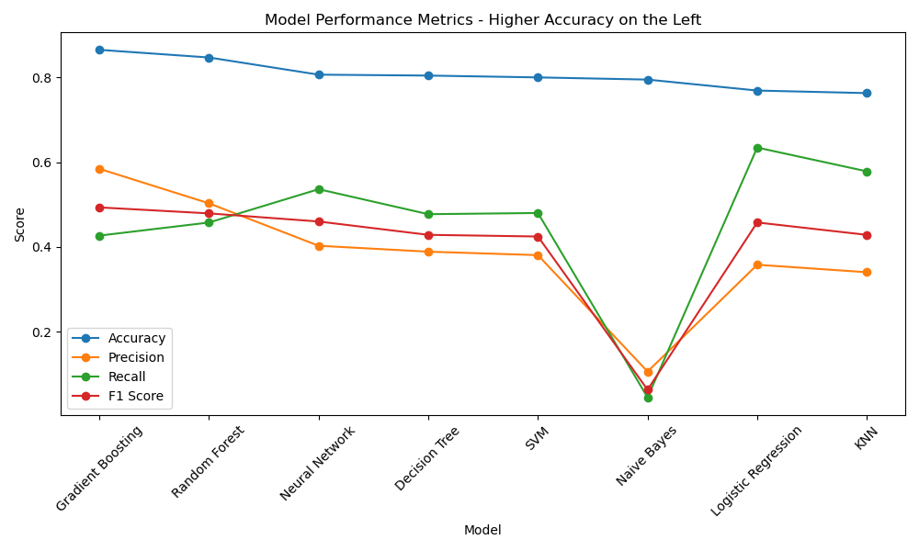

The following table summarizes the performance of the models based on key metrics:



Considering the trade-off between performance metrics and computational efficiency, the following observations apply to the highest ranked models:

* Gradient Boosting achieved the highest accuracy (88%), with a good balance between precision and recall, making it one of the top-performing models.
* Random Forest demonstrated a strong F1 Score performance (48%) and had a high recall compared to other models.
* Neural Networks also performed well with an F1 Score of ~46%, benefiting from its ability to capture complex patterns in text embeddings.
* Logistic Regression, KNN and Naive Bayes underperformed, due to their inability to effectively manage complex interactions between features.

**Model Comparison Strategy:**

1. A stratified train-test split was applied to maintain class balance across published and unpublished papers.
2. Class imbalance was treated using the standard SMOTE package for under/over-sampling.
3. Cross-validation (5-fold) was used for all models to ensure robustness and reduce overfitting risks.

**Final Model Selection Criteria:**  
The final model was selected based on its balance between accuracy, precision, recall, and F1 score:

* Gradient Boosting was chosen as the optimal model due to its high accuracy (87%) and competitive F1 Score (49%). It effectively utilized features like abstract_keyword_count, comments_keyword_count, and BERT embeddings for predictions.

**Key Observations:**

* Feature importance analysis was applied and showed that text-based features (abstract_keyword_count, abstract_embedding_bert_feature_combined) were critical for predicting publication likelihood.
* Models like Random Forest and Gradient Boosting benefited from ensemble techniques, which improved generalization by combining multiple decision trees.
* Neural Networks showed promising results but required significant computational resources for hyperparameter tuning.
* Class imbalance (70% unpublished vs. ~30% published) was solved using standard SMOTE package features for under/over-sampling techniques.

**Limitations:**

1. Computational constraints limited BERT embeddings to a max_length=16, potentially reducing their effectiveness in capturing nuanced textual information in more detail.

**Recommendations:**

Researchers seeking to increase the probability of having their research papers published in a relevant vehicle should do the following:

1. **Look for the characteristics of peers who succeeded in publishing papers to search for other peers with papers published or not.** The peers who succeeded in publishing demonstrated the “right behaviors” of having a “good” paper, therefore it is worth reading papers that show similar characteristics. This is also valid for peers seeking to improve the probability of having their papers published. See below for the description of the key characteristics.
2. **Optimize the keywords used in the “title” and “abstract” of your paper.** Title and abstract keywords used in the paper were relevant predictors of the publication success.
3. **The number of pages and figures of your article matters.** The number of pages and figures are higher predictors of the probability of a paper being published. Intuitively, smaller papers have more chance to find the “space” in the research vehicles, and people tend to prefer short, precise content to read.
4. **Contact your peers who have already succeeded in publishing various papers and learn their ways. Read their papers to understand their practices.** Authors with higher success rates in publishing papers may detain unique tips and tricks to help succeed in a publication. Our models showed that the frequency of publication by a single author is a high predictor of success. Learning from other’s experiences is a must-do. Reading papers (published or not) that follow this pattern – that is, demonstrate similar characteristics of the successfully published papers – will optimize the researchers time by directing them to potentially higher-quality papers to read first, given a certain topic.

The table below shows the Top 4 Features for the best models using a color scheme that represents the recommendations described in this session:

The detailed Top 9 features are as follows:



Metadata of the features present in the table (top features selected by the models):

* num_pages: Number of pages of the paper.
* num_figures: Number of figures of the paper.
* submitter_frequency: Frequency of paper submission (number of papers) for that author.
* abstratct_keyword_count: number of AI keywords present on the “abstract” column (using a predefined set of 500 top AI keywords).
* comments_keyword_count: number of AI keywords present on the “comments” column (using a predefined set of 500 top AI keywords).
* title_keyword_count: number of AI keywords present on the “title” column (using a predefined set of 500 top AI keywords).
* update_year: year that the paper was updated for the last time.
* version1_year: year that the first version of the paper was published.
* The remaining features named “tfidf” or “bert” are tokens and embeddings from the columns title, abstract and comments.

**Note: Brief Considerations on Relating Publication with High Paper Quality**

* The assumption that journal publication equates to higher paper quality is an imperfect proxy.
* While publication in a peer-reviewed journal is often used as an indicator of quality due to the vetting process and peer reviews, this approach has important limitations.
* The relationship between publication and quality can be misleading due to factors such as selective submission practices - authors may preferentially submit their best work for publication, or prominent researchers may receive preferential treatment, inflating the perceived quality of published papers.
* Additionally, acceptance decisions in journals and conferences are influenced by subjective reviewer judgments, institutional prestige, the need to publish a certain, high visible topic, and other biases, meaning that not all high-quality papers are published, and not all published work is of high quality.
* Therefore, using publication status as a proxy for paper quality risks confounding content quality with paper visibility, author’s reputation, or strategic behavior rather than objective merit on the paper quality.
* As a conclusion, while publication is correlated with quality, it is not a definitive or unbiased measure, and the model’s predictions should be interpreted as such.

**Detailed Model Results**

The detailed plots with the results are below:

**Model Performance Metrics:**



**Bias versus Variance** (Note: not relevant for all models):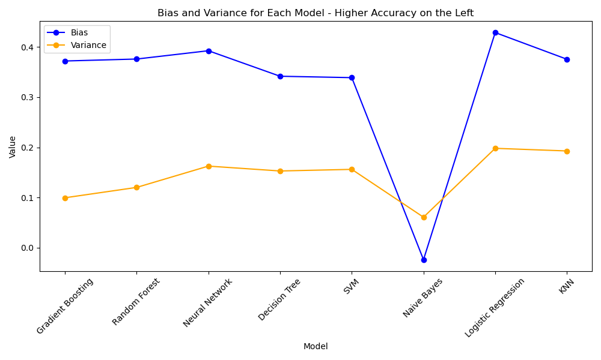

**Confusion Matrices for All Models:**

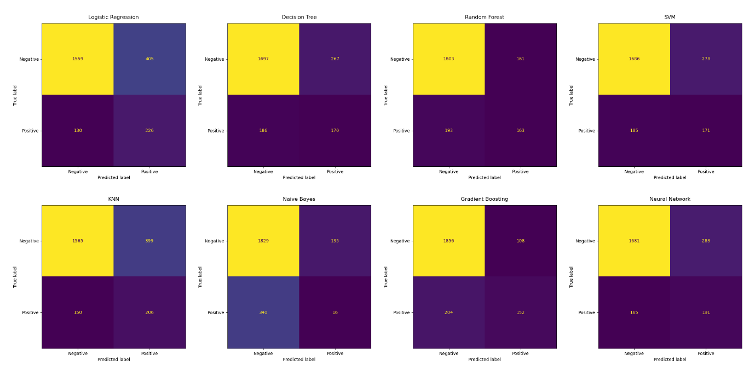

**Next Steps: Integrating the Publication Prediction Model into arXiv.org:**

ArXiv.org can implement this model to enhance the user experience, help researchers navigate the vast volume of preprints, and provide actionable insights to both readers and authors of its library:

1. **Use as a Triaging Tool:** arXiv.org could integrate the publication prediction model as a triaging tool to help users quickly identify preprints with a higher likelihood of journal publication. This would allow researchers to prioritize their reading, focusing first on papers that the model predicts are more likely to meet peer-review standards and be published.
2. **Create Filter and Ranking Criteria for Users:** the model could be embedded as a filter or ranking option within arXiv.org search and discovery user interface, like how other current recommender systems suggest relevant articles based on user interests (Netflix, Spotify, and others). For example, users could sort or filter new submissions by “predicted publication probability,” streamlining literature reviews and saving time.
3. **Provide Feedback to Authors:** authors could receive feedback and recommendations on their submissions, with the model highlighting features that increase publication likelihood-such as keyword optimization in titles and abstracts, or patterns observed in successful papers-enabling them to refine their manuscripts before journal submission.
4. **Analyze Publication Potential (Internal Triage):** arXiv.org moderators and editors could leverage the model for internal triage, flagging papers with high publication potential for further visibility, or identifying papers that may benefit from additional support or community feedback.
5. **Implement Opt-In Feature:** the integration could be piloted as an opt-in feature, ensuring transparency and allowing the community to provide feedback and suggest improvements to the paper.

## **Appendix 1. Detailed Plots**

This Appendix 1 contains all the 57 plots of data originated from the Preprocessing Phase that provides more details about the data being used.

